


EARN COLLEGE CREDIT WHILE STILL IN HIGH SCHOOL!



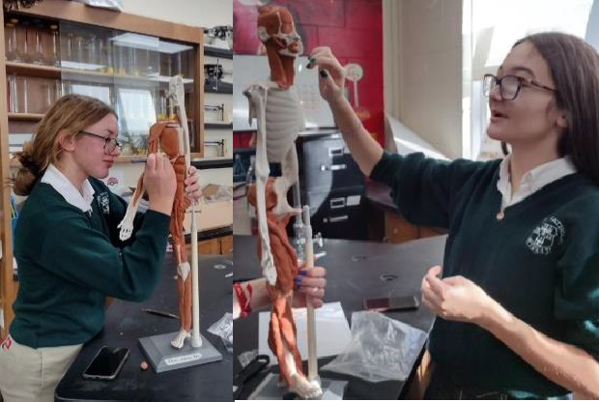
Geibel Catholic Junior Senior High School

611 E. Crawford Avenue Connellsville, PA 15425

Phone: 724-628-5600
Fax: 724-626-5700
www.geibelcatholic.org

College in High School
2025-2026

Seton Hill University Saint Vincent College Mount Aloysius College

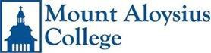

Geibel Course SHU Course Credits
Geibel Course | SVC Course | Credits
CHS 2-D Art | AR 131 Point, Line And Beyond | 3
CHS 3-D Art | AR 135 Materials And Process | 3
CHS Music Theory | MU 115:  Fundamentals of Music Theory | 3
College Calculus | MA 111: Analytical Calculus I | 4
College Calculus II | MA 112: Analytical | 4

CHS Calculus SMA 130: Calculus 1 4
w/ Analytical Geometry
CHS Calculus II SMA 140: Calculus II 4
Survey of SFR 105: Elementary
French Literature French Language & 3
Culture II
Geibel Course MAC Course Credits

Survey of Spanish SSP 105: Elementary
Literature Spanish Language 3
& Culture II
Principals of SEL 151: Topics 3
Literature in Literature
Composition SEL 105: Composition 3
& Rhetoric & Culture Part A
CHS World SRT 285: Topics in Theology 3
Religions
CHS Probability & SSS 250: Introductory 3
Statistics Statistics

The cost is $235 per course.

Calculus II
Physics: NSCI 130: Intro to 4
Physics & Lab
CHS French IV FR 203: Intermediate 3
French I
CHS Survey of FR 204: Intermediate 3
French Literature French II
CHS Spanish IV SP 203: Intermediate 3
Spanish I
CHS Survey of SP 204: Intermediate 3
Spanish Literature Spanish II
Each of our three participating schools has a different registration deadline and cost. Students may take course offered by more than one school. Registration forms are available in the Guidance Office and should be returned with proper payment to Ms. Smith.

Please contact Ms. Smith, School Counselor, with any questions.
CHS World TH 308: World Religions 3
Religions
CHS Cybersecurity CS125:Fundametals 3
of Cybersecurity

The cost for a 3 credit class is $264.

The cost for a 4 credit class is $352

CHS Probability MAT 220: Intro to Statistics 4
Honors  Chemistry II | CH 101: Chemistry I | 4
Anatomy & | BL 116: Anatomy & | 4
Physiology | Physiology
CHS 3-D Art | AR 115: Making | 3
 | Your Mark: Drawing As Revelation
College Calculus | CM 117: Calculus 1 | 4

& Statistics

CHS American HGPA201:American History to 1877 3
History HGPA202:American History since 1877 3

CHS College CH112: College Algebra 4
Algebra

The cost for a 3 credit class is $216
The cost for a 4 credit class is $ 288

